Assignment 8
NAME = HARSH RAJ
ENROLLMENT NO = 2503B09912
PROGRAM = MCA
Q1. A process is a program in execution. In real CPU scheduling, processes do not always arrive at the same time.
The First Come First Serve (FCFS) algorithm schedules processes in order of arrival time.
Requirements:
- The program should accept:
  - Number of processes
  - Arrival Time (AT)
  - Burst Time (BT)
- The program must sort the processes in ascending order of arrival time.
- The CPU may become idle if the next process arrives later. Your logic must correctly handle idle time.
- Calculate for each process:
  - Completion Time (CT)
  - Turnaround Time (TAT = CT – AT)
  - Waiting Time (WT = TAT – BT)
- Display the result in a formatted table and print:
  - Total TAT and WT
  - Average TAT and WT
- Use non-preemptive FCFS.
Given System State
Consider the following processes:
Process | Arrival Time | CPU Burst Time
P1 | 2 | 4
P2 | 1 | 3
P3 | 0 | 1
P4 | 3 | 2
CODE
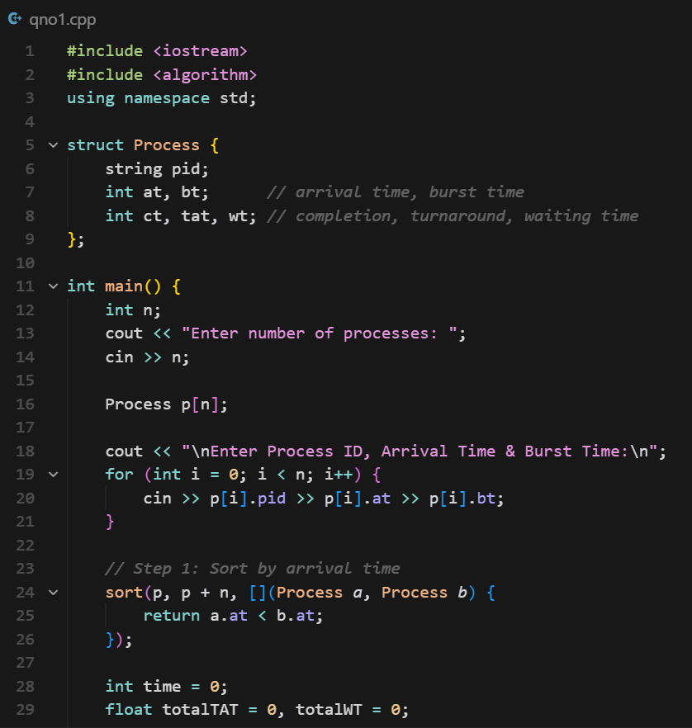
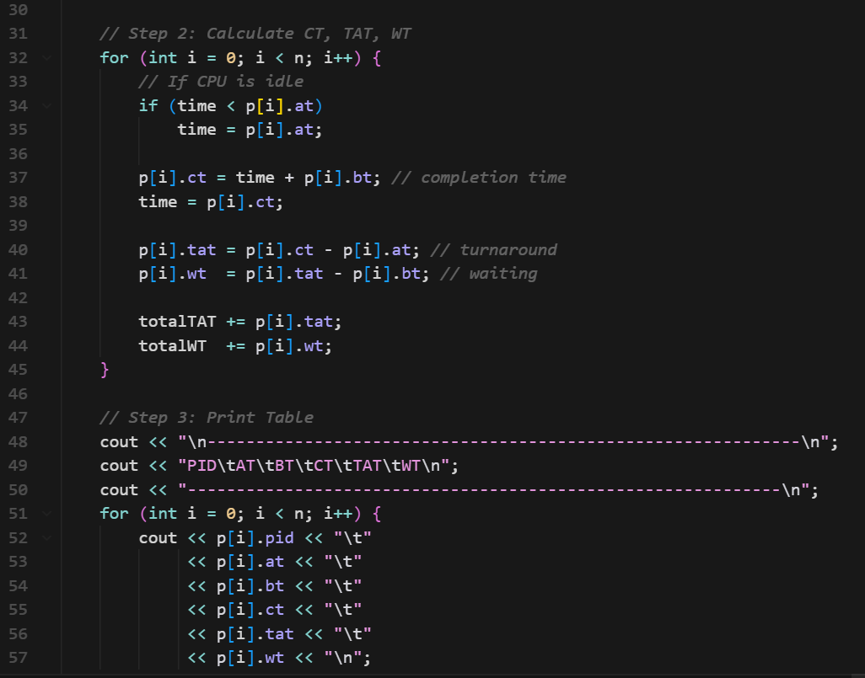
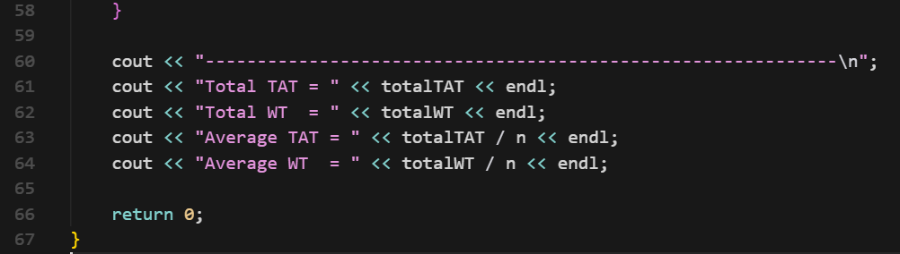
OUTPUT
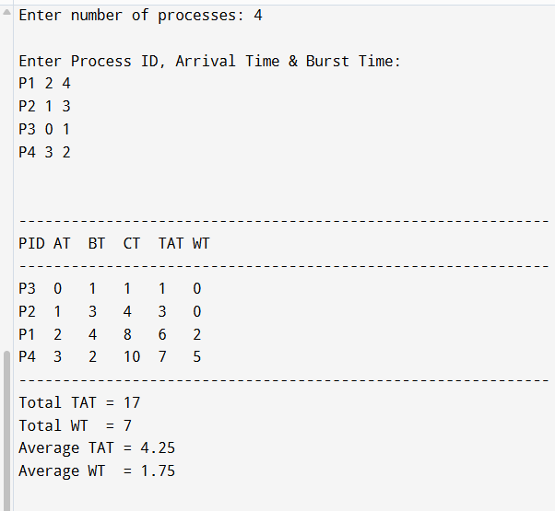

- Assignment Question: Implement SJF (Shortest Job First) Scheduling Algorithm
A process is a program in execution. CPU scheduling determines which process gets the CPU next.
The Shortest Job First (SJF) algorithm selects the process with the smallest CPU burst time next.
SJF can be:
- Non-preemptive → process runs until completion
- Preemptive (SRTF) → process may be interrupted if a new shorter job arrives
In this assignment, consider Non-preemptive SJF.

Problem Statement
Given the following processes:
Process | Arrival Time | CPU Burst Time
P1 | 0 | 8
P2 | 1 | 4
P3 | 2 | 9
P4 | 3 | 5
Task:
Implement the Non-Preemptive SJF Scheduling Algorithm to calculate:
- Completion Time (CT)
- Waiting Time (WT)
- Turnaround Time (TAT)
- Average Waiting Time
- Average Turnaround Time
- Gantt Chart
CODE
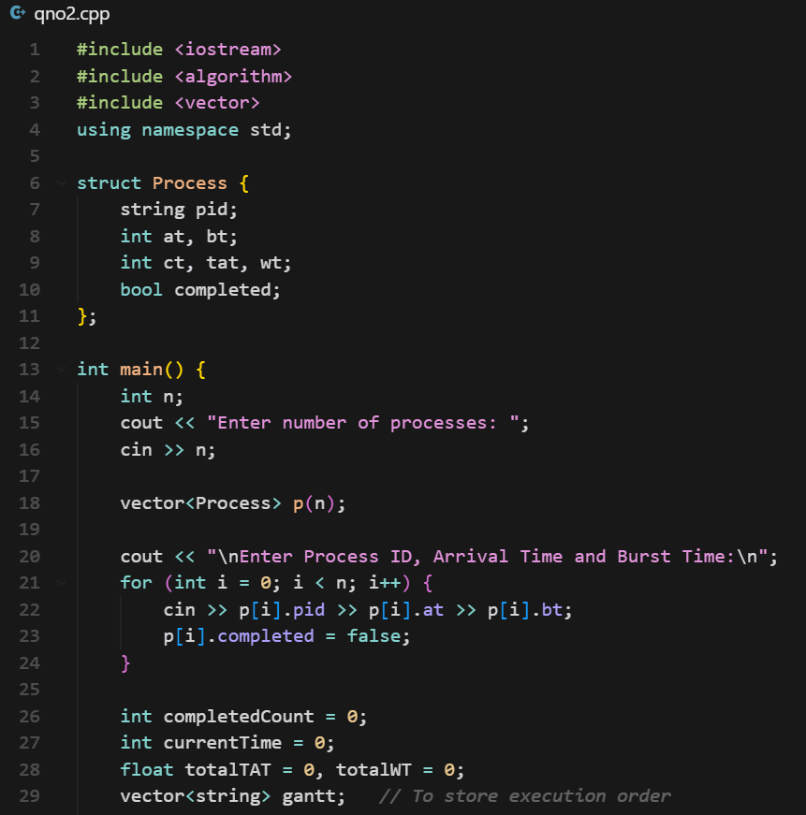
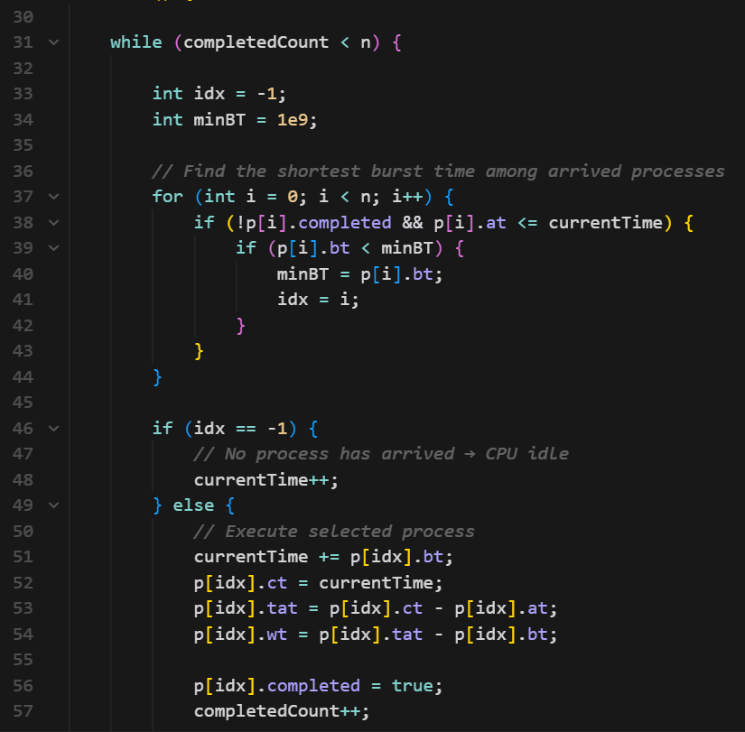
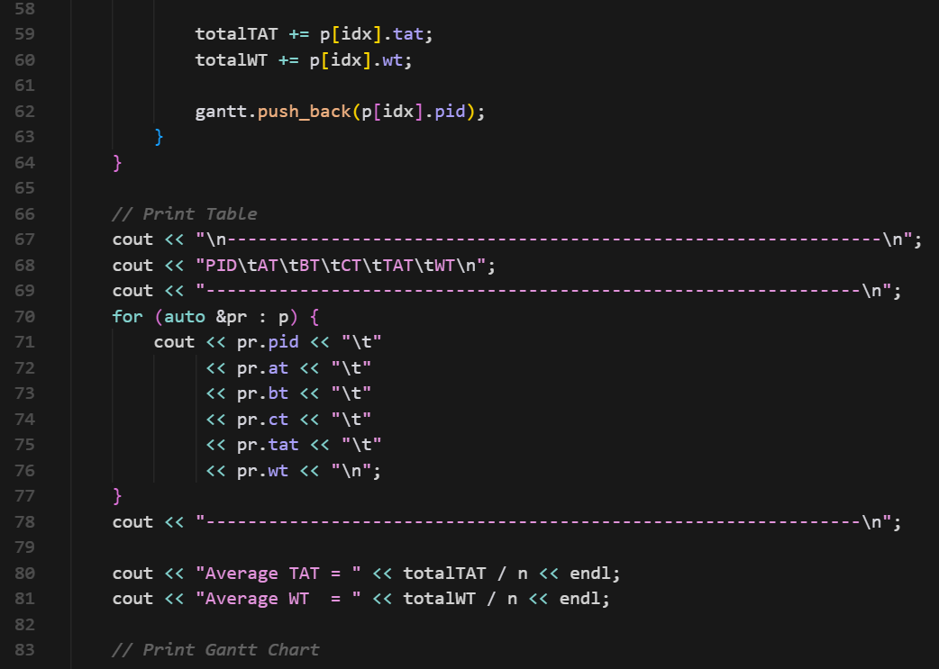
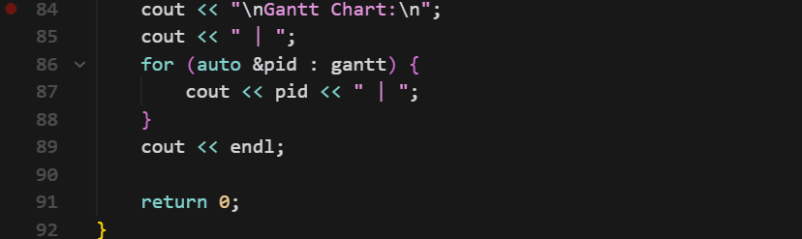
OUTPUT
